
SCHOOL OF COMPUTING AND ENGINEERING SCIENCES (SCES)
BACHELOR OF SCIENCE IN ELECTRICAL AND ELECTRONICS ENGINEERING (BSEEE)
BEE 2302: PCB DESIGN AND FABRICATION
GROUP 5
TRAFFIC LIGHT SUBSYSTEM:
MCU (Atmega328) with wireless communication using LoRa to Back
end and local Zigbee with Master Node or Slave Node Configuration.
By:
Edward Aribu Mwongela
142092.

SUMMARY OF COMPONENTS
Picture | Component Description and Name on your Schematic | Packaging  (Footprint  Type) | Quantity | Unit | Cost | Amount
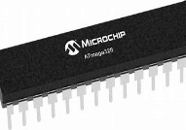 | ATMega328P | 28-pin Dual Inline Package (DIP). | 2 |  | 200 | 400
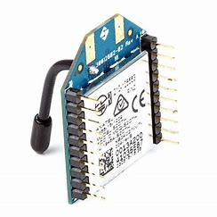 | Xbee S2C (ZigBee Transceiver) | XBee SMT | 2 |  | 4000 | 8000
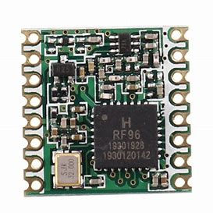 | RFM95 LoRa Transceiver 868 MHz | Surface-mount package/ (SOIC) | 2 |  | 900 | 1800
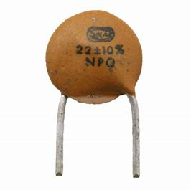 | 22 pF Ceramic Capacitors | 0805 package | 4 |  | 60 | 240
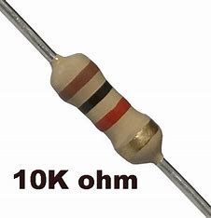 | 10 kOhm resistor | Axial Lead | 2 |  | 15 | 30
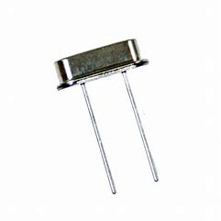 | 16 MHz crystal oscillator | HC49/US | 2 |  | 310 | 620
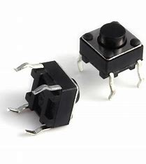 | Pushbutton | DIP (Dual Inline Package) | 2 |  | 400 | 800
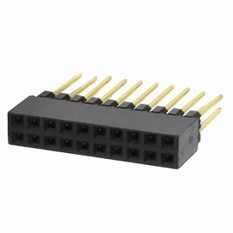 | 10 Pin 2.54mm Female Header | Dual Row Straight Header | 5 |  | 5 | 25
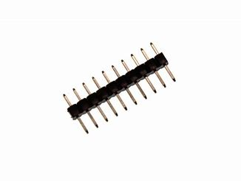 | 10 Pin 2mm Male Header | Dual Row Straight Header | 2 |  | 5 | 10
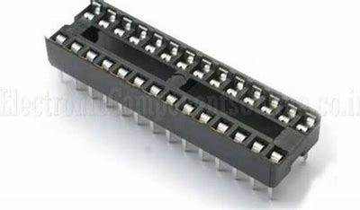 | 28 Pin DIP IC Socket | Through-Hole Package | 2 |  | 5 | 10

4. Gerber files
Gerber files are a standard file format used in the electronics manufacturing industry to describe printed circuit board (PCB) designs. They contain the necessary information for the fabrication of PCBs, including the layout of copper traces, pads, holes, and other features on the board.
The Gerber file format is named after the Gerber Scientific Instrument Company, which originally developed it. Today, it has become a widely accepted industry standard for PCB manufacturing. Gerber files are typically generated by PCB design software or computer-aided design (CAD) tools used by engineers and designers.
The information in Gerber files is presented in a series of ASCII text files, with each file representing a different layer of the PCB design. These layers can include the top copper layer, bottom copper layer, solder mask, silk screen, and others, depending on the complexity of the design.
PCB manufacturers use Gerber files to generate the necessary tooling for the production of PCBs. The files are processed by specialized software that converts the information into machine-readable instructions, such as commands for creating copper traces, drilling holes, applying solder mask, and so on.

The files to be sent to the production companies should include the following elements:
- Gerber (RS-274X): This is the most basic Gerber file type, and it contains the information for the copper layers of the PCB. It specifies the location and size of all the copper traces, pads, and vias.
- Gerber (RS-274D): This is an older version of the Gerber format, and it is not as widely used as RS-274X. However, some PCB manufacturers may still require it.
- Gerber (MIRROR): This file is a mirror image of the copper layer Gerber file. It is used to create the solder mask layer, which protects the copper traces from solder.
- Gerber (Soldermask): This file contains the information for the solder mask layer. It specifies the location and size of the areas that should be covered by the solder mask. For example, Top Mask
- Gerber (Silkscreen): This file contains the information for the silkscreen layer. It specifies the location and size of the text and graphics that should be printed on the PCB. An example is Top Silk
- Gerber (Drill): This file contains the information for the drill holes in the PCB. It specifies the location, size, and type of each drill hole.
- Gerber (Aperture): This file contains the information for the apertures that are used in the Gerber files. Apertures are the shapes that are used to create the copper traces, pads, vias, and solder mask openings.
- Gerber (Job): This file contains the information for the entire PCB manufacturing process. It includes all of the Gerber files, as well as other information such as the board dimensions and the layer stackup.
- Gerber (Edge): This file contains the information for the edge of the PCB. It specifies the location and size of the board outline, as well as the drill holes that are used to attach the PCB to the PCB substrate.
- Gerber (NC Drill): This file contains the information for the non-copper drill holes in the PCB. These holes are used to mount components to the PCB, and they are not covered by the solder mask.
- Gerber (Assembly): This file contains the information for the assembly process. It specifies the location of the components on the PCB, as well as the component footprints. For example, Bottom Paste.
File Type | Purpose
Gerber (RS-274D) | Copper layers
Gerber (RS-274D) | Older version of RS-274X
Gerber (MIRROR) | Mirror image of copper layer Gerber file
Gerber (Soldermask) | Solder mask layer
Gerber (Silkscreen) | Silkscreen layer
Gerber (Drill) | Drill holes
Gerber (Aperture) | Apertures
Gerber (Job) | Entire PCB manufacturing process
Gerber (Edge) | Edge of PCB
Gerber (NC Drill) | Non-copper drill holes
Gerber (Assembly) | Assembly process

6.Fabrication
PCB fabrication and component assembly processes are done in an extremely clean environment where the air and components can be kept free of contamination. Most electronic manufacturers have their own proprietary processes.

Film Generation
The board image is generated on a film in this initial step. Each layer generates one film. The Gerber files, which are sent to the manufacturer or manufacturing facility where the negative image or mask is produced on a plastic sheet, are used to create the film. These films are often produced by manufacturers using a photo plotter.
Black ink is used to depict the conductive copper components of the PCB for the inner layers of the PCB. The areas of non-conductive material are indicated by the remaining clear area of the image. The outer layers have the reverse pattern: black for the area that will be etched away and transparent for copper.

Etching
Etching is used to get rid of copper traces on the substrate that aren't necessary. There are numerous etching options available, all of which are based on various sorts of compounds like ammonium persulfate, ferric chloride, etc. The most widely used substances are hydrochloric acid or ferric chloride. The PCB is placed on a chemical bowl and cleaned with a brush throughout this process.

Electroless Copper Deposition (Plating)
A thin layer of copper is chemically placed into the through holes to make them conductive so that electrical connections can be made to various PCB layers. Later, this copper will be electrolytically plated to make it thicker.

Solder Mask
On a PCB board, the solder mask tends to be the green coating. Except for pads and vias, the PCB board is typically covered in solder mask. The mask's main function is to limit the areas that will be soldered over. During assembly and installation, it also shields panels from contaminates, handling scuffs, and potential electrical shorts.

Silkscreen
On the component side, the silkscreen is typically used to identify the component, the test point, the PCB part number, the warning symbol, the company logo, and the manufacturer marks. Ink jet printing is used for this.

Surface finish
With two primary purposes—preserving the exposed copper circuitry and providing a solderable surface for attaching components to the PCB—the Surface Finish is the most significant step between PCB production and PCB assembly. Surface finish serves as a "coat" for copper by being situated above it and at the PCB's outermost layer.
Each form of surface finish has a unique function (dependent on the environment the PCB must operate in and the requirements of the assembly process) and a unique application technique. The most common are Immersion Silver, Immersion Tin, HASL (Hot Air Levelling), OSP (Organic Surface Protection), ENIG (Electroless Niquel Immersion Gold), and Electroless Niquel Immersion Gold.

Drilling
The drilling device is operated by a computer. From the Gerber files, the operator chooses the PCB drill file. It specifies the X-Y coordinates of the holes as well as the drills the machine should utilise. To create a solid foundation for effective plating on the hole walls, high speed drilling assures clean hole walls.
Due to the need to drill each hole separately, drilling takes time. The changing of drill bits is totally automatic. The device chooses the required drill bit from the drill bit rack, verifies its size, and then puts it into the drill bit head. Typically, drilling is done simultaneously on stacks of working panels (up to 5).

Electrical test
Making ensuring the PCB is error-free and up to expectations for quality is one of the final tasks of the PCB production process. For the high-volume testing of PCBs today, there are various automatic testing devices available.
Circuitry opens and shorts are checked for on PCBs. A computer programme that instructs the electrical test unit to apply a modest voltage to each contact point and then checks to see if a specific voltage manifests at the correct contact points constitutes the fundamental component of all tests.

Assembling
The process of soldering or assembling electrical components to a printed circuit board is known as PCB component assembly. Surface mount technology (SMT), throughhole assembly technology, or a combination of both may be used during a PCB manufacturing process. The component leads are placed into the PCB holes using the first technique. The ICs are positioned or fastened on top of a pad that has legs similar to the PCB design in the latter manner.
(Prof.Mwangi_Mbuthia - Google Drive, n.d.)

